An Open Architecture Distortion Meter

Motivation
The motivation behind the development of this distortion meter was a mix of the following:
- I wanted to make distortion measurements on audio power amplifiers.
- I had built and used analogue distortion meters using a variety of TwinT filters, cancellation approaches and – well anything else I could scrounge up. The success of this approach is very dependent on the amount of fiddling you are willing to undertake and the complexity of the circuit.
- I had restored older HP meters, but hit limits on the minimum distortion they would measure.
- I did not want to shell out significant amounts of money on a commercial unit. From what I could see, this would be in the region of A$10k to get something that would do the job.
- The “middle of the road” units, such as the quantasylum QA400 almost did the job, but fell short on their performance at low distortion levels.

Oh, and I had built a bunch of analogue to digital and digital to analogue converters, and was convinced that with a little tweaking these would be able to be configured into a distortion meter.

As it turns out, I ended up redesigning both the A/D and D/A subsystems to varying degrees.

Approach Taken and Resultant Architecture
The approach I wanted to take was driven by the following key decisions:
- The system should have exchangeable A/D and D/A subsystems.
  - The interface chosen was that I have used on previous DSP's.
  - The interface is a 26 way IDC connector, with every second wire grounded, a standard I2S interface comprising SCLK, MCLK, LRCLK, SDATA, lines for SPI into the card allowing control of volume chips etc – though these were not used in this design, +3V3 digital, +5V Analogue, +9V Analogue, -9V Analogue.
  - Note the +/-9V lines are arbirary, and I use these for op amps, sometimes I run these at +/-15V.
- The system should interface to the PC using USB
  - That said, the system should be galvanically isolated from the PC. Without galvanic isolation the ground noise in my experience absolutely kills any chance of getting a real low noise measurement or measurement of spurs at low levels. .
  - I am happy to design this from scratch, but do want this to be a USB interface and really want this to hook into the windows audio subsystem.
  - I also decided that this is a pure test and measurement system, and it did not need to auto sense sample rates / word widths. Take this as a note of caution, there are jumpers on the A/D and D/A boards that set this. In fact if I recall correctly, the DAC uses 10k pullup resistors for this.
- The system should use existing measurement software
  - There are some decent free ware and low cost packages out there.
  - My software development skills and interest extend as far as embedded C on micro-controllers, but I know that I would lose interest in developing a windows application well before it was complete.
- The system should be mains operated.
  - I don't like batteries they go flat and leak the moment you forget they are in a box.
- The system should be able to measure the output of a 200watt power amplifier without external attenuators.
- The system needs to have a differential input, as without this noise between the A/D and D/A ground references will dominate.

The result is that I would up with the following physical subsystems:
- A power supply that has two independent, isolated, +/-15Volt regulated outputs.
- A MiniDSP USB Streamer interface.
- A backplane comprising local regulated rails, galvanic isolator for the MiniDSP interface, clock generators and headers for the A/D and D/A's.
- An analogue to digital converter board based on the CS5381 ADC.
- A digital to analogue converter board based on the CS4398 DAC.
- A differential to single ended input with attenuation control for two channels.

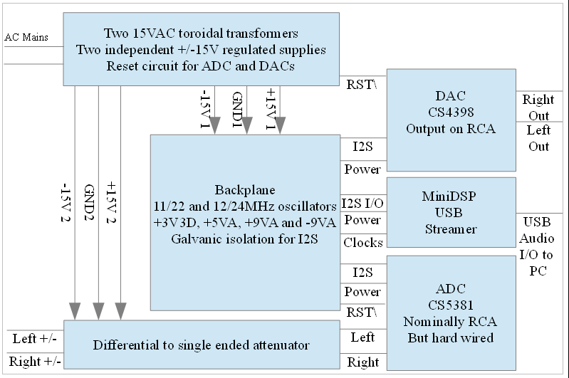

Key Subsystems
The following subsystems were bought in or made:
- Dual galvanically isolated power supplies
- MiniDSP USB Streamer
- Backplane and Regulators
- Balanced to single ended converter and attenuato
- A/D
- D/A

Dual Galvanically Isolated Power Supplies
The power supply design is fairly conventional. The only real distinguishing feature is that the main power supply board does a “first regulation” to DC, then the following boards drop this down to the required lower voltages.

The reasoning was that I did not want AC ripple running around on ground lines – even if these were not being used for reference purposes.

The regulator schematic is shown in the figure below. A few notes for young players:
- I have a tendency to use LM317/LM337 regulators in a very casual manner. Watch the resistor values around them, as for anything other than 3.3V and 5V, I tend to select the output voltage as I build the regulator.
- By my quick and dirty calcs, 220R and 2K7 will give a rail in the region of 16V.
- The reason for this is that my SMD collection is a rather large set of reels of 1% resistors, of which very few are E12 or E24 values!!! Choose your voltage as you build:)

The reset circuit was pretty simple, as all I was looking for was an open collector pulldown to reset the CS4398 and CS5381:

This was built on a single sided PCB with separate transformers and output rails.
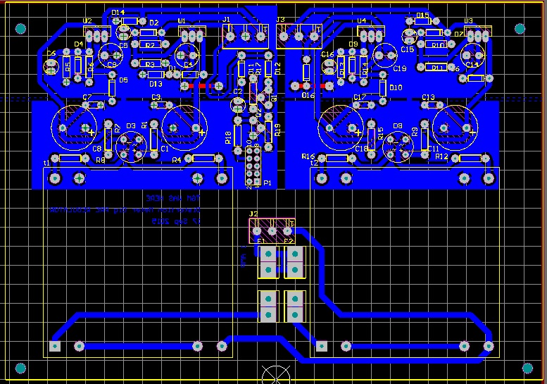

There are very few things to note here, aside from:
- Ensure adequate separation between the AC mains side and ANYTHING else. I used 8mm as a minimum, which exceeds any domestic standard.
- Make sure that the “noisy” parts of the ground wiring from the transformer to the main storage caps is separate from the low noise side. I put a cut in the ground fill and placed a track across so I could control where the ground currents flowed.
- Remember that you will probably want a flag heatsink on some of the regulators. There is no need for things to become stinking hot, but I like things to be cool enough to hold onto – i.e. below 60 degrees Celsius.
- I wrapped a copper shorting ring around the transformers in a vain attempt to minimise noise induction into the front end of the system. It did no good.

Things I would change next time I built this – kind of a good chance I will do one of these for the shed sound system, but no guarantees!
- Placement of the resistors between the diode bridge and regulators. If you short the regulator out there is an even chance you will make smoke from these.
- I am not convinced they do anything useful, though they probably do limit peak currents. The downside is that if you short out the power supply you might need to replace these. I would either replace these with wire links, or put them in a place where they are easy to replace.
- The fuses for the transformers are in an inconvenient spot. This was half intentional as I did not want them to be where “fingers might find them”. I have stuck plastic over these for safety. There might be a better way to deal with these.

MiniDSP USB Streamer
I used the MiniDSP USB Streamer. Ref: https://www.minidsp.com/products/usb-audio-interface/usbstreamer
OK this might look lazy.
OK, it is lazy.
But here is the thing. I am aiming for a solid measurement system here, and while my inclination to design stuff had me perilously close to trying on my own design of the XMOS interface IC, in the end I concluded that that is not the point here.
MINIDSP have done all the legwork with the windows driver, licensing the IC and making a neat little embeddable board.
As at Jan 2016 the board is US$105, which hits that sweet spot for me of “Wow, that is not cheap, but damn at that price I can't be stuffed doing it myself.”. Well done MinDSP sales team:).
Now, here is the thing. The MinDSP does provide:
- USB to I2S audio Output – quite common
- USB to I2S audio input – very uncommon
- Lots of channels – though I only use two of each, though I did make provision for many more on the I/O card.
That sounds great!!! but MiniDSP have not delivered the perfect solution for me in that:
- The I2S interface is connected straight to the USB ground. Not a great thing!
- The clock generation they have used is based upon a Cirrus Logic CS2300-03. This has a number of consequences.
The CL CS2300-03 used on this product has been custom programmed to generate the clocks that drive the MiniDSP and consequently the I2S interface, from a 300Hz base clock! This is “OK” for audio, but won't set any phase noise records.
For really tight measurements we want to have a clock right at the A/D and D/A with a nice clean signal.
So there are two things we need to do with the MiniDSP interface:
- Galvanically isolate it on the backplane board
- Generate some nice clean clocks for the A/D and D/A
- Work out how to lock this all together.
This is the top part of the datasheet. The part number on this device gives little away as to what exactly it is. It took me ages to find this, but here it is!

The brutal approach that I took was to disconnect the output of this PLL and inject my own clock into the MiniDSP USB Streamer, which is sourced from the “Clean side” of the galvanically isolated backplane. Read later for what I mean by “Clean Side” and “Noisy Side” of the backplane. But essentially:
- Anything with a ground reference on the PC / MiniDSP USB Stremer side is “Noisy Side”
- Anything on the backplane, galvanically isolated from the PC, and referenced to the A/D and D/A is “Clean Side”.
For a much more friendly approach, and one that deals with various clock rates, get onto JENSH on diyaudio.com. With a little subtlety it is possible to select the clock and A/D and D/A modes. I couldn't be bothered as this to me is a hardcore measurement system. It does mean that my PC needs to be left at 192KS/S, 24 bit audio, but so what?
The following aspects are addressed in the backplane section:
- How to galvanicaly isolate the LRCLK, SCLK, MCLK and SDATA lines of the MinDSP USB Streamer.

Backplane, Regulators and Galvanic Isolation of USB Streamer
The Backplane, Regulators and USB Streamer interfaces all go onto the one board. They perform the following functions:
- Local regulation of the pre regulated 15 volt rails to moderately isolated lower voltage rails.
- Implement galvanic isolation of the MiniDSP USB Streamer from the measurement system.
- Generate clocks
- Route signals between the MiniDSP USB Stremaer and the A/D and D/A subsystems
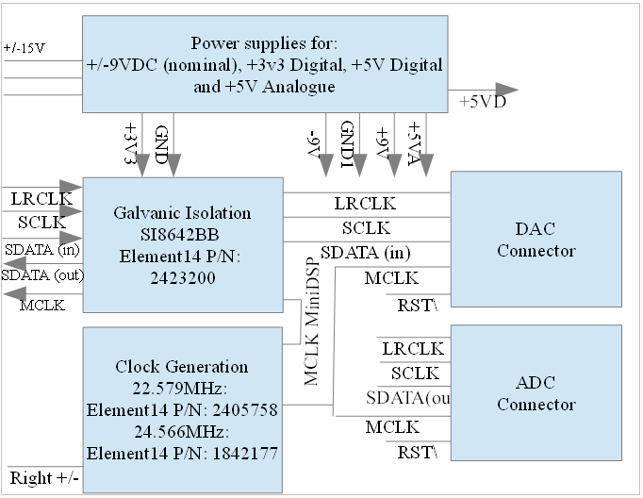

Local Regulation
The local regulation is quite straight forward. The board was laid out assuming that the input might be AC, so there are fuses, a diode bridge and storage, as well as a bunch of regulators.
The area to b careful of, again, is where ground currents will flow and what is the “clean ground” point on the PCB. I defined this with a link between these ground domains.

Again, there may be a need for heatsinking on some of the regulators depending on the current drawn. In particular I have noticed that the AK5394 draws more current on VA than the CS4398, and a flag heatsink on the VA regulator was required. I tend to use PIC microcontrollers to implement user interfaces and do general “control stuff”. I have included an interface to allow me to stick one in here, as that is what I would use to set sample rates etc. To date I have not used that, and I suspect that I won't given the system is up and running.

The layout is far from awe inspiring for this part of the board. The only vague area of difference might be that R7 forms the link from the PSU ground to the ground plane, which is on the top layer of the board.
The board is 2 layer, which means that I can make it in my shed – a real consideration given that I have the patience of a not-very-patient-thing. It also means that I can bang out a PCB for about AUD5$, which means I can run through prototypes without getting all hung up about cost.
With +/-15 Volts in, you can expect the 3.3 and 5V rails to dissipate a bit of heat.

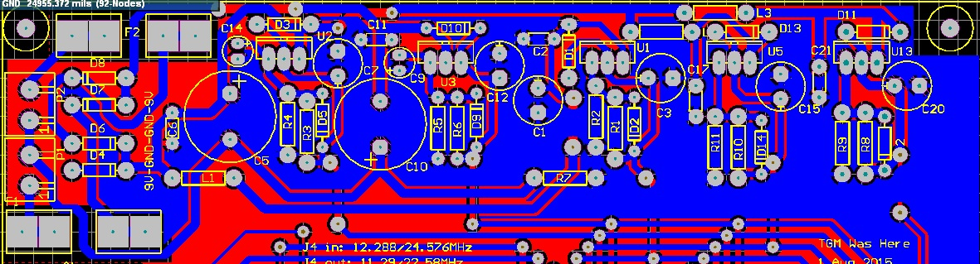
Note that the above excludes the caps on the VA and 5V regulators. The ALTIUM files include these now.

Galvanic Isolation of USB
The galvanic isolation is right in the middle of the I2S interface. You don't want big delays between SCLK, SDATA and LRCLK. The system is 3.3V on both sides which is convenient.

I chose to use the silicon labs SI8642BB digital isolator. These have a propagation delay of less than 10ns, which is fine for an I2S interface which runs at a SCLK of way under 12MHz. That preceding brave statement was made without me knowing the skew on the output of the MiniDSP USB Streamer, but once I have it all together it proved very stable. The circuit is extremely simple. The reason I chose the SI8642BB was that I could get away with buying a single type of IC to do both input and output on the board. A small thing but it does save me a few dollars in buying two types of IC.

On the MiniDSP side the 3.3V supply and MiniDSP ground need to be pinched from the MiniDSP card. These will be found on a bypass capacitor.
U4 looks after the system clocks, LRCLK, SCLK and MCLK.
U6 and U7 deal with channels 1-8 input and output, noting that I2S puts two channels on each stereo stream.
Layout in this part of the board was more concerned with ensuring isolation between the “Noisy Side” that being the MiniDSP side, and the “Clean Side” that being the main backplane which connects the A/D and D/A.
This is the board layout of this section:
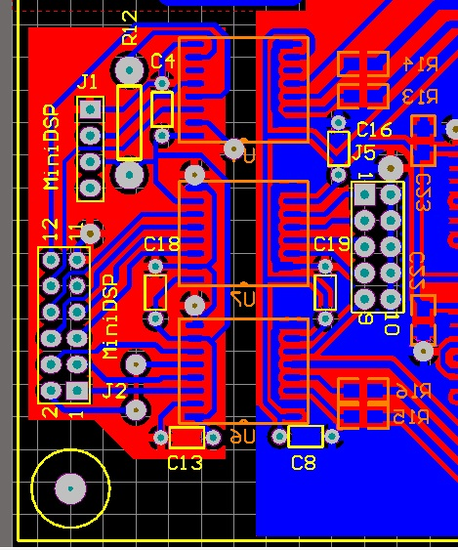
Things to note:
- R12 is really a wire link. But since I laid this out as a double sided board, I did not want to put a track right through the ground plane there. So this is really acting as a pseudo “third layer”, and ensures integrity of the top ground plane.
- There is a distinct separation between the “noisy” and “clean” domains.
- I did use through hole capacitors in here, which might be gutsy. They do however form nice “vias” between the top and bottom ground planes. Anyway 12MHz is not all that high a clock speed.
- J2 is laid out one for one to the MiniDSP header, so a nice ribbon cable does the trick.
- J1 pinches the MiniDSP ground, 3V3 and drives the nice clean MCLK clock signal back into the USB Streamer.
- I have made provision for series termination resistors on the drive lines. I have loaded 100 Ohms, as this is give or take the impedance of the clock lines if my quick calculations worked. Looking at these signals on an oscilloscope shows a relatively clean signal which I was happy with. I never had any trouble with clocks, so have never thought of tuning these.

Clock Generation
The system has a potential need of the following clocks:
- 22.579MHz / 11.289MHz
- 24.576 / 12.288MHz
The MiniDSP wants the higher clock frequency fed back to it. This allows these nice clean clocks on the “Clean” side to drive, and thus lock the USB Streamer.
Note: The USB Streamer uses these clocks to generate SCLK, LRCLK and SDATA, and subsequently drives these back to the A/D and D/A across the I2S interface, so ultimately the “Clean” clocks driven into the USB Streamer are the master clock for the system.
I thought about using crazy expensive oscillator modules. Then I stopped. I was not convinced that they were necessary, though somebody might show me otherwise. The devices I used were straight from Farnell.
- 22.579MHz: Element14 P/N: 2405758
- 24.566MHz: Element14 P/N: 1842177

There is a divide by two section and a multiplexor to select the clock driving the A/D and D/A. Additionally I have used the shutdown pins on the oscillator modules to try reducing noise in the system from unused clocks.
Note: This has changed a few times, in the end I needed versatility on clocks to allow CS4398 DAC and AK5394 ADC, each of which wanted different MCLKS!!!

You need to ensure that the MiniDSP gets the clock it is after, and many A/D and D/A converters want a clock rate of half of this. The multiplexor forms a convenient way of selecting and driving both of these.
If I were doing this again I might:
- Use separate Multiplexor outputs to drive each of the MCLK lines to the A/D and the D/A separately.
- I have not seen evidence that this is an issue, but this is the highest clock rate signal, and also the most important in terms of noise / jitter for the A/D and the D/A. So given there are spare gates, I should have run these lines through.
You will note I have reverted to SMD bypass caps and termination resistors. This area I really want to be nice and clean, to which end getting the bypasses right onto the IC's is a big deal.
Unfortunately, making these PCB's in my shed means that I do need to solder wires through these holes, which kind of defeats part of the benefit of using the SMD device, but that is a price I must pay.

This is this section of the PCB:
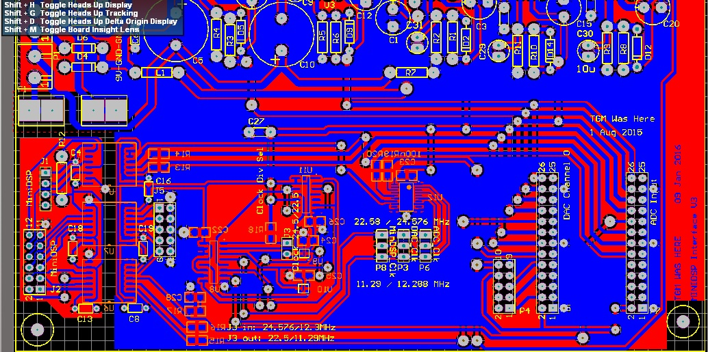
Note: The crystal oscillator modules are tiny, and I mean tiny, 2.5mm square. You will want a good magnifier for this, I used a microscope. I imagine a jewelers loupe would work OK though. To solder these down I used a lot of flux, then tacked one corner and simply soldered the other corners pads, allowing a bit of time for the flux to activate and draw the solder under the remaining pads. I did the for each corner. I have done a dozen of these now, and all have worked.
I have simply used jumpers to set the clock frequencies. If you want to do something more sneaky, these jumpers are 3.3V logic inputs. The design by JENSH would plug right onto here.
Things I would change next time: Going with a 2 layer board is probably running things a bit close to the wind in this area, if I were getting this board made in a fab, I would definitely go 4 layer, especially for the clock section and bussing to the I/O connectors.

Route Signals
The signal routing is really just bussing wires to 26 way headers. The header pinout is the same for ADC's and DAC's. In part because I am lazy, and in part because I am stupid and expected to, and have, plugged ADC's onto DAC headers on a regular basis. A common pinout avoids smoke, at least from the PCB!
The headers are:
Things I would change: The CS5381 does not have SPI bus control. It was an act of profound stupidity not to route it through though.
Things I would do differently next time: I would probably consider using extra channels of the digital isolators to drive LRCLK and SCLK to the ADC and DAC each. That is, not string LRCLK and SCLK such that the digital isolator gets reflections from both of the cables. This would be a bit more expensive on the isolators, but would achieve point-to-point drive for these lines with minimum delay.

Balanced to Single Ended Converter and Attenuator
This is an extremely important part of the system. You absolutely need to have a differential input which converts to the ground reference of the ADC. This means that you want something like:
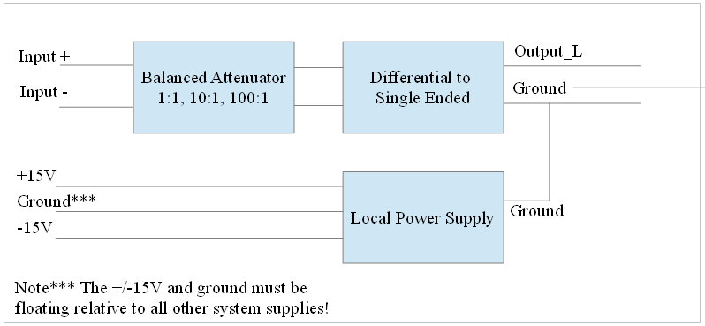

I was on the cusp of laying this out – having decided on using a design presented by Douglas Self, when a local electronics magazine published pretty much exactly what I wanted. Here is the web link: http://www.siliconchip.com.au/Issue/2015/May/Balanced+Input+Attenuator+For+Audio+Analysers+%2526+Scopes There is more than an even chance that you will need to subscribe to get access to the article. I cannot help you there.
The PCB and precision and more specialised surface mount parts are sold by Silicon chip, here: http://www.siliconchip.com.au/Shop/?article=8560
This gives you a neat little PCB that provides the attenuation and also does a decent fist of a low noise differential to single ended conversion by using paralleled NE5532 (or whatever your favourite dual channel op amp is).
I did replace the switching on the front end for a relay board, as I was concerned at noisy switched causing more distortion than the signal itself.
The looks like:
The PCB looks like:
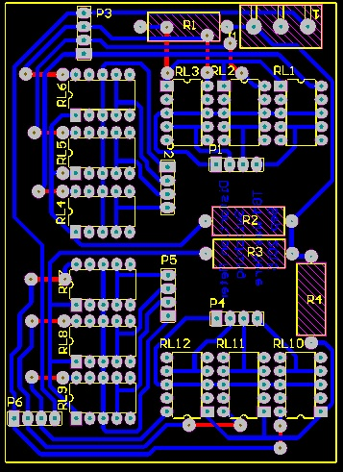
There is no ground plane in here as this is switching the differential signals. Without knowing the layout of the differential attenuator board, it will not be obvious, but the only sensitive tracks on this board are those on P1, P2, P4 and P5. The loops between these and pins 3 and 4 plus 7 and 8 of the relays are what I am worried about. This part of the layout came out pretty neat. All the rest is switching voltages for the relays.
The layout of the allows it to be soldered directly on top of the Silicon Chip Balanced Input and Attenuator board.
Just to reiterate: There is no way you can sensibly avoid using a balanced input board. If you don't I am pretty sure you will end up where I found myself without it – hitting a floor at about -105dBc THD+N which was caused, I am quite sure, by noise between the earths of the A/D and D/A.
Things I would change:
- I have built an ADC that has a direct differential input. I am strongly tempted to drop this into the meter, but then I still need to put switched attenuators on it.
- Be cautious – while the ADC has a “differential” input, it realy wants this driven as a balanced input with notionally identical positive and negative signals driving it. The input you need for the distortion meter needs to be truly differential, where the negative input is connected to say, the ground of a signal, and he positive to the signal you want to measure. This allows the differential receiver to cancel out ground noise etc. The “negative” line in this case has a very small voltage and the positive pretty much the full signal being measured. Don't mistake this with “balanced”!

Digital to Analogue Converter
The ADC started out as my normal CS4398 DAC that I use in my DSP's. This did pretty well but not perfectly. Aiming to squeeze the last dB or so of THD perfromance out of it, I laid out a PCB with identical filters on each of the positive and negative differential outputs.
Whilst it is difficult to nail down sources of noise and distortion at such low levels, I am confident that there was a benefit in changing from a simple single op amp differential to single ended convertor to two identical filters driving a differential to single ended output.
The schematic is otherwise pretty unsurprising if you have read the Cirrus Logic or AKM design notes.
This is the 26 pin header to CS4398 section of the circuit:
Note: This layout is for 48KS/S. I had to jumper M3 and M2 to set it to 192KS/S. Things I would change next time are to add jumpers for M3 and M2!
The DAC output stage is as noted above not wildly amazing – just more complex that the normal application note published by Cirrus.
Note: The schematic shows 100uF electrolytic capacitors C1, 22, 26 and 34. These couple the output from the DAC to the filters. These are not loaded. The LM4562 I have used here is happy with that offset, and avoiding these devices just makes sense. The output of the LM4562 is pretty much ground referenced – but I do use a DC block cap on the output.
The PCB still has the PGS2320 on it. If you want really low distortion don't even load this! The distortion that this generates is much greater than the CS4398. In fact in terms of implementing a volume control, you are better off using the CS4398 to do this in the digital domain – at least as far as sensible audio applications go.
The layout looks like this – at least showing the bottom layer.
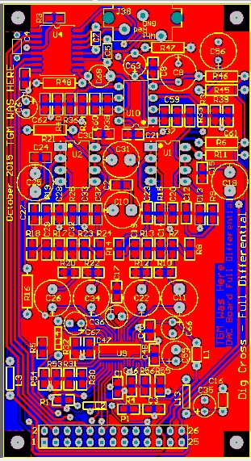
Things of note on this board:
- The actual filter part around U1 and U2 is “very” similar to an application note published by AKM.
- You need to be super careful about keeping the digital and analogue stuff apart. This board keeps all the digital between the connector and the CS4398.
- You need to get bypass caps right on the IC. There are both power supply and reference voltage caps.
- The differential outputs to the filters need to be kept tight. The layout seeks to keep things close and symmetrical.
- You must use NPO capacitors in the filter. These are in some cases reasonably large values for NPO types, and not the sort of thing that you pick up from your local hobbyist shop, at least not in Australia. Your more professional companies have them. I stuck to 0805 to keep things easy to solder.
- The differential to single ended converter needs to have the resistors very well matched. I hand matched a batch of resistors to probably <<0.1%.
- DONT use the PGA2320. I jumper past this. The reason this made it onto the board is so that I can retrofit these into my DSP crossover. It increases distortion, a lot!
Things I would change, and one or two that I would not:
- I am toying with the idea of putting a local regulator on this board to generate the +5VA from the 9V supply.
- I am toying with the idea of balanced output. But then I wonder what I would do with that other than drive it into the ADC to measure self distortion!
- I have tried NE5532 and LM4562 op amps. I cannot say I have seen a measurable difference.
- I toyed with taking the PGA2320 off, but I want it there for reasons other than the distortion meter.

Analogue to Digital Converter
The Analogue to Digital converter caused me some headaches. Mainly because I started with a reference design that frankly sucked. It worked ok for the CS5361, but was disasterous for the CS5381.
Key aspects of the design are:
- A very symmetrical input drive to the ADC. It needs to be balanced and differential.
- Tight control of the input offset to the ADC's reference voltage.
- A low impedance drive to the ADC that can handle the rather obnoxious load that it presents to the driving amplifiers.
- Use of NPO capacitors across the ADC input, with extremely low impedance at RF is essential. Use of pretty much anything else I tried didn't come close. This included styro and all manner of other types.
- Do the single ended to balanced conversion properly, and match the resistors in this part of the circuit as well as possible. Again, hand match them to <0.1%. Note: I have a bunch of reels of components, simply running off say 100 resistors allows me to quickly select a few sets of four that are really close in value to one another. OK, so I bin a bunch of resistors, but I picked the reels up for $2 each as surplus.
- The inverters show 4K7 resistors on the schematic. This is nominal, and a lower value will give lower noise. I used 1k33, again matched to a high level. This struck me as a low enough value to keep noise down, but no so low that between the feedback resistor and following op amps that the LM4562 would be overloaded.
I included limiting diodes on both the input to protect the input operational amplifiers from voltage excursions that exceed the supply rails, and at the input to the ADC to protect this from drives going below ground or above VA. Tests show that these have no effect on the distortion that I can measure.
I used aluminium electrolytic coupling capacitors to the differential drive. These are not fancy, and are simple polarised types. These work fine, and again appear to have no obvious impact on performance. There is no need for bipolar devices here as you know there is a +2.5Volt DC offset across these.

The schematic is:
This is a screen dump of the PCB. There is noting amazing about the layout, a quick perusal of the CS4398 design guide will lead you in the right direction.
Again, I have done this as a double sided PCB. Again, if I were getting this made at a fab, I would go 4 layer. That said, there are very few tracks on the top of this board, and the ground plane retians a good level of integrity. Going to a fad would save me loading a bunch of links between the ground planes and to the tracks on the top of the PCB.
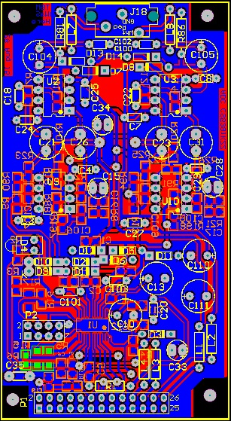

Integrating it Together
I stuck this all into a “rack mount” case that I knocked together in the shed. The main criteria for this were:
- To provide screening for the system.
- To provide a safe enclosure for the system, as it is mains powered.
- To allow it to fir on my desk with other “stuff” on it.

Things I would do differently:
- I would not bother with single ended inputs.
- I would put the XLR connectors further from the attenuator switches!
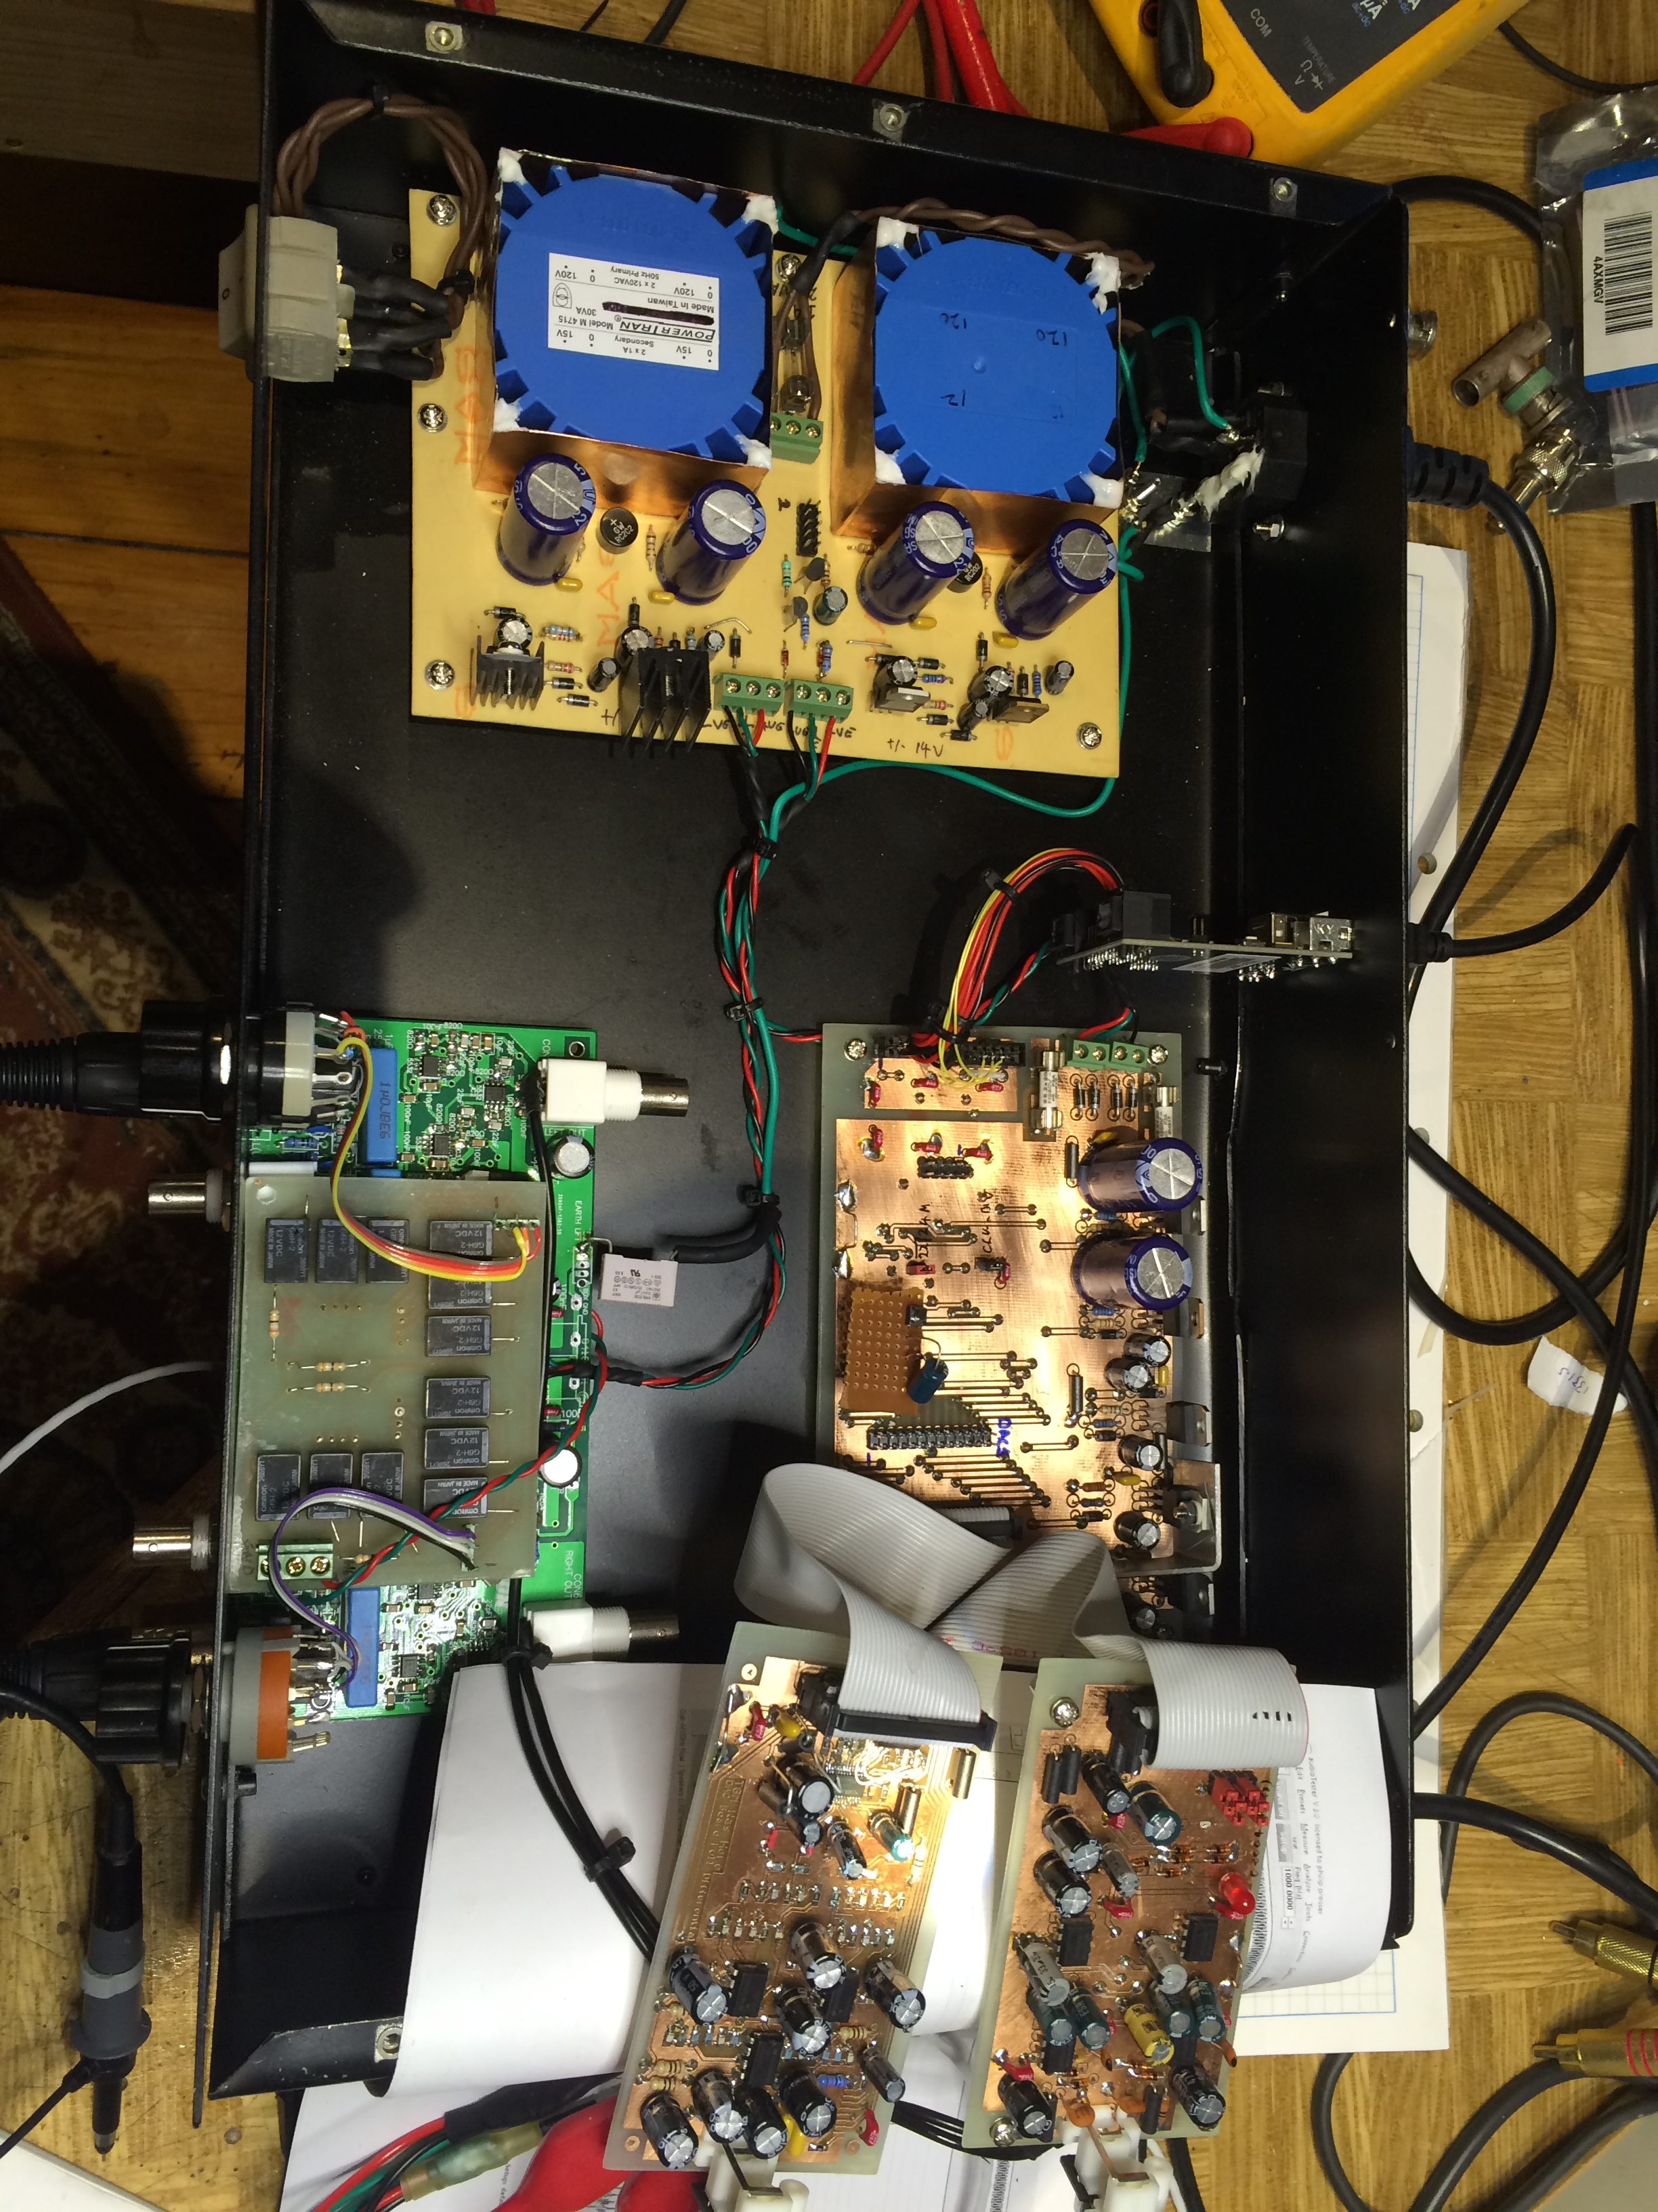
I should stick in a picture of it finished.

Costs
This is not an exercise I have done yet. The following may perturb me as I write it!

Subsystem | Description | Cost (A$) | Notes
Power Supply | Dual independent power supply. | 60 | This cost is a wild guess. Excludes PCB.
MiniDSP USB Streamer | MiniDSP part | 130 | US$105
Backplane, clocks, usb isolator and regulators |  | 50 | This cost is a wild guess. Excludes PCB.
CS5381 ADC Board | Stand alone ADC board | 60 | This cost is a wild guess. Excludes PCB.
CS4398 DAC Board | Stand alone DAC board | 60 | This cost is a wild guess. Excludes PCB.
Silicon Chip Differential attenuator |  | 80 | Much of the cost is in the precision components
Case | And various bits like input connectors, fuses etc. | 50 | Made this in my shed...
Total |  | $490.00

Don't take the above too seriously, other than to note that you wont knock one of these up for $10. I have not costed bills of material for this, and I have literally stacks of bits that I use without buying in all the bits. The real cost could be 50% above or below this.

